© 2018 IJSRST | Volume 4 | Issue 2 | Print ISSN: 2395-6011 | Online ISSN: 2395-602X

Themed Section: Science and Technology

Evaluation of Feature Extraction Techniques using Neural Network as a Classifier : A Comparative Review for face Recognition

## Vinodpuri Rampuri Gosavi1, Dr. G. S. Sable2, Dr. Anil K . Deshmane3

1IEEE Student Member, G. S. Mandal’s, M.I.T, Aurangabad Maharashtra, India

2Professor,, G. S. Mandal’s, M.I.T, Aurangabad Maharashtra, India

3Professor and Principal J.S.P.M.’s B.I.T., Barshi, Solapur, Maharashtra, India

# ABSTRACT

Face recognition has a wide range of possible applications from person identification and surveillance to electronic marketing and advertising for selected customers. In facial recognition, there are different steps such as preprocessing, feature extraction and classification where feature extraction and classification are used to obtain maximum accuracy. In this research paper, different feature extraction techniques such as ASM, AAM, Gabor features, Template based, and several are critically reviewed. Apart from these, the different types of neural classification networks such as convolutional, backpropagation, radial basis function etc. in the domain of facial recognition are explored. The methods and algorithms developed in the current literature are studied and it is revealed that all the techniques are unique and have optimal performance. This research further makes a comparative analysis of these techniques based on their advantages and limitations.

**Keywords :** Face Recognition, Feature Extraction Techniques, Artificial Neural Networks, Accuracy

# INTRODUCTION

A pattern-recognition system is used for identification or authentication of users, based on their unique physical properties [1]. Recognizing individuals through their faces is an important phenomenon and the task of recognizing peers through their faces effortlessly performs in our daily life. The primary features are represented using a suitable feature representation scheme and learn the discriminating features over which matching algorithms perform. The different phases of typical face recognition systems are involved. The plenty of face recognition methods have been designed that are performing well in controlled environments. It includes some of the prevalent methods such as principal component analysis [2], linear discriminant analysis [3], Fisher

face [4], independent component analysis. A variety of face representation methods have been proposed in recent years [5] and they are categorized into two types such as that holistic feature representation [6] and local feature representation. As a representative pattern recognition problem, there are two main procedures in a practical face recognition system such as face representation and face matching. Most existing local feature descriptors are hand-crafted [5] which usually require strong prior knowledge and are heuristics.

Among the most widely cited methods for face recognition based on feature extraction are Eigenfaces based on Principal Component Analysis (PCA), Fisher faces based on Linear Discriminant Analysis (LDA), and methods based on Independent Component

IJSRST1841253 | Received : 07 Feb 2018 | Accepted : 17 Feb 2018 | January-February-2018 [ (4) 2: 1082-1091]

1082

Analysis. A novel and also pose invariant face recognition system depend on a deformable, generic 3D face model that is combination of an edge model, a color region model, and a wireframe model for describing the shape and also important features of the face. The first two models are employed for image analysis and the third mainly for face synthesis. To match the model to face images in an arbitrary pose, the 3D model can be projected onto different 2D view planes based on rotation, translation and scale parameters thereby generating multiple face image templates

Machine recognition of human face from still and video images has become an active research area in the field of image processing, pattern recognition, neural networks, and computer vision. This is having wide applications ranging from static matching of controlled format photographs such as passports, credit cards, driving license and also the real time matching of surveillance video images presenting different constraints in terms of processing requirements. A general and efficient design approach using a radial basis function (RBF) neural classifier to cope with small training sets of high dimensions, which is a problem frequently encountered in face recognition, is presented in the above research conducted and hybrid learning algorithm is implemented for the study [7]. The principal component analysis is one of the most popular multivariate statistical techniques [8] has been widely used in the areas of pattern recognition and signal processing. There are numerous PCA based methods used for face recognition from one dimensional PCA to two directional two-dimensional PCA. This research method promotes the accuracy compared to one dimensional PCA, two dimensional PCA and two directional two-dimensional PCA.

The major challenges are developing an accurate real time face recognition system which does not require high computational cost and the existing researches

were conducted on real time face recognition system by using block processing of local binary patterns of the face images captured by the NAO humanoid. Similarly, a method that included NAO humanoid and being tested under real world conditions were demonstrated [9].

# LITERATURE REVIEW

There are several techniques proposed by different authors regarding various feature extraction techniques and also a neural network for face recognition. These techniques are explored and discussed in the succeeding sections.

## Geometric based feature extraction

In geometric-based approach, the local features (local statistics and locations include mouth, eyes, eyebrows, and nose are at first extracted from face images. The most important geometric based methods are Active appearance graph models.

1. **Active shape model(ASM):** A model for face recognition based on the local matching gabor consisting of three main modules and one of which is Active state model where image alignment is done and is used to align the face has been proposed. Besides, to determine the shape with the intent of extracting features from corresponding points relative to gallery image and the module for the spatial position of the gabor jet ASM has been used to adjust the face pose as shown in Fig.1[10]. This is a linear statistical model which uses a linear transformation in vector space and this model uses point distribution model where a vector defines the shape of the object. An efficient and suitable algorithm for facial landmarks which is used in most of the mobile devices has been postulated [11]. In this research the original ASM has been modified to improve its performance with three changes such as improving the initialization model using center of the eyes by using feature map of color information and constructing

modified model definition and fitting more landmarks than the classical ASM and the last change is constructing 2D profile model for detecting faces in input image and the method is evaluated on dataset containing over 700 images of faces.

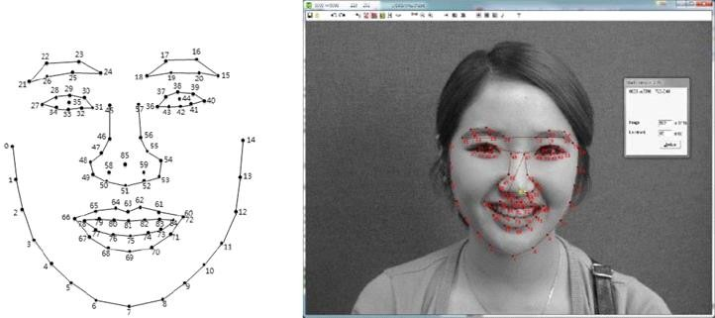

**Figure 1.** Facial features landmarking scheme used in the classic ASM implementation

1. **Active appearance model(AAM):** A novel method of interpreting images using this model were demonstrated [12]. This model contains a statistical model of the shape and the grey level appearance of the object of interest. These models were generated by combining the model of shape variation with a model of appearance variations in a shape normalized form. Thus, it is concluded that AAM algorithm will be an important method of locating deformable objects in many of the applications. A method for classifying facial expressions based on the extracted features of facial components was presented [13]. The facial region is detected and then it is processed using active appearance model to extract the vital feature on the facial components.
2. **Scale- invariant feature transform(SIFT):** A model for fuzzy match index for scale invariant feature transform features which involve all the SIFT key points in decision making process were presented [14]. This SIFT is primarily designed for object recognition applications such as face recognition, iris recognition, fingerprint identification and so on. SIFT features are good for characterizing the background and outdoor scenes. In this, the new fuzzy SIFT classifier is adapted successfully for robust face recognition from complex backgrounds without any face cropping tools and

using single template and also the development of a highly efficient fuzzy descriptor matching tool. Thus, this research allows for weak supervision of the face recognition experiment. The scale invariant feature transform works well only for pose variation and fails to produce satisfactory results under varying illumination were demonstrated [15]. Further, hybrid scale invariant feature transform with weighting factor in feature matching is proposed which uses a fixed facial landmark localization technique. This research has been implemented in OpenCV to give a recognition rate of 98%.

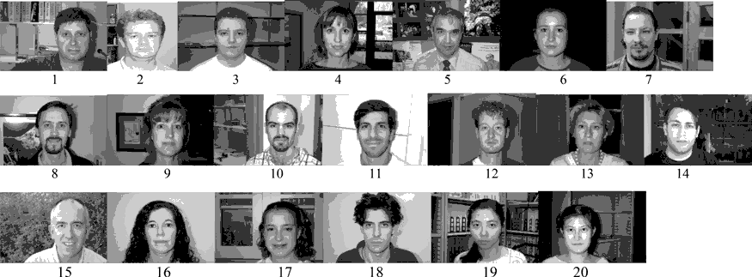

**Figure 2.** Twenty training templates from the CALTECH-256 Face database [30] are shown with subject IDs

## APPEARANCE BASED FEATURE EXTRACTION

This method is usually used for frontal face detection using color images-based feature extraction and appearance-based classification. Face detection with certain degree of accuracy and robustness uses low level image features such as color and shape.

1. **Local Binary Pattern(LBP):** The method for face recognition in uncontrolled environment which works with local binary pattern of facial images has been presented [16]. The basic method of filtering the LBP surface texture is developed and this method is tested on different databases having uncontrolled facial images and the obtained results are shown that this method works well in these uncontrolled

environments and is represented in Fig 3. The real time face recognition system where block processing of local binary patterns of the face images captured by NAO were demonstrated [17]. These NAO humanoids are used in robot-human interaction applications. This method has been adopted on NAO humanoid and tested under real world conditions and this technique overcomes the conventional and the state odd art techniques.

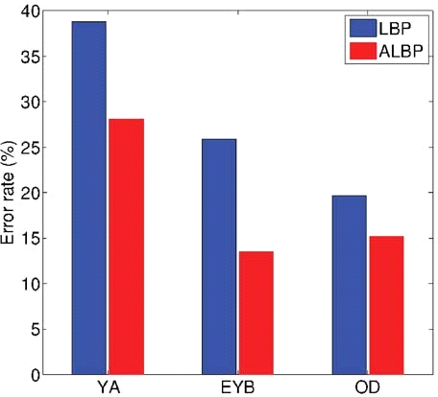

**Figure 3.** Histogram plot of Equal error rate (EER) rendering pitfalls of the local binary pattern (LBP) and augmented local binary pattern (ALBP) in application of Bra Curtis dissimilarity metric

1. **Gabor features:** Gabor features in face recognition were presented to improve the performance [18]. Here the gabor based method is used which modifies the grid from which the gabor features are extracted using mesh to model face deformations produced by varying pose and also statistical model of the scores are computed by using gabor features to improve recognition performance.

A cloud based ubiquitous monitoring system via face recognition is proposed [19]. This research reduces gabor filter complexity by maintaining local features. This research specifies novel method for center symmetric local binary pattern feature extraction algorithm.

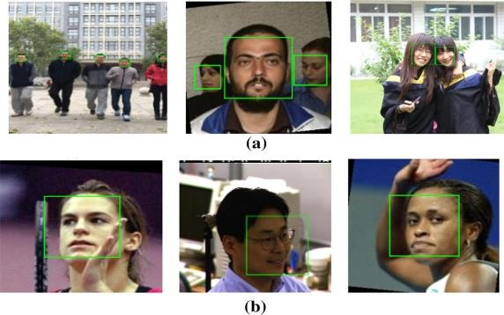

**Figure 4.** Results of face detection. a Multi-face dataset. b Single face dataset

1. **Principal component analysis(PCA):** A patch based principal component analysis method to deal with face recognition is demonstrated [20]. The utilization of correlation between pixels, columns, rows takes place but the local spatial information is not used in these techniques and it is observed that patches are more meaningful basic units than pixels for face recognition. This method has the highest accuracy when compared to one dimensional PCA, two dimensional PCA, and the two-directional two- dimensional PCA.

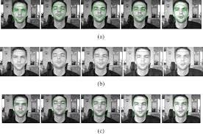

**Figure 5.** Bio ID Face Database

For recognizing a human face based on the features derived from the image was demonstrated [21]. The detected face in the image is recognized using a fusion of principal component analysis and feed forward neural network. This method uses Bio Id face database as standard image database as shown in Figure 5.

## Template based feature extraction

The various approaches implemented for determining the features of faces in recognition are describes in the below section.

1. **Deformable templates:** A method for detecting and describing features of faces using deformable templates is presented [22]. This explains about feature of interest for example if we take eye as an example and it is described by a parameterized template then this template interacts with the image by altering its parameter values. The final parameters can be used as descriptors for the feature. Thus, deformable templates are used to features in real images. An algorithm of extracting eye contours from face image using deformable template matching method where the algorithm explains that the digital color face image is converted into binary image of representing eyes is demonstrated.
2. **Gravity center template:** A gravity center template for face location by extracting edges and regions around the organs the original image is processed and also, these are scanned to detect the organs has been proposed [23]. This procedure is fast and shape of the face features is characterized.

A model to locate and track driver's mouth movement using a CCD camera to study on monitoring and recognizing a driver's yawning were presented in [24] At first detecting driver's faces using gravity center template then detecting driver's left and right mouth corners by grey projection and also extracting texture features of driver's mouth corners using gabor wavelets

## Artificial neural networks for face recognition

There are several neural networks proposed by different authors regarding various feature extraction techniques for face recognition and are discussed as follows.

1. **Back Propagation neural network:** A back propagation neural network algorithm as the main and efficient approach to the machine learning when the data includes the complex sensory input such as images were demonstrated [25]. The partial derivative of the cost function with respect to any weight or bias is an expression for back propagation. This network shows how easily the cost changes with change in weights and biases.

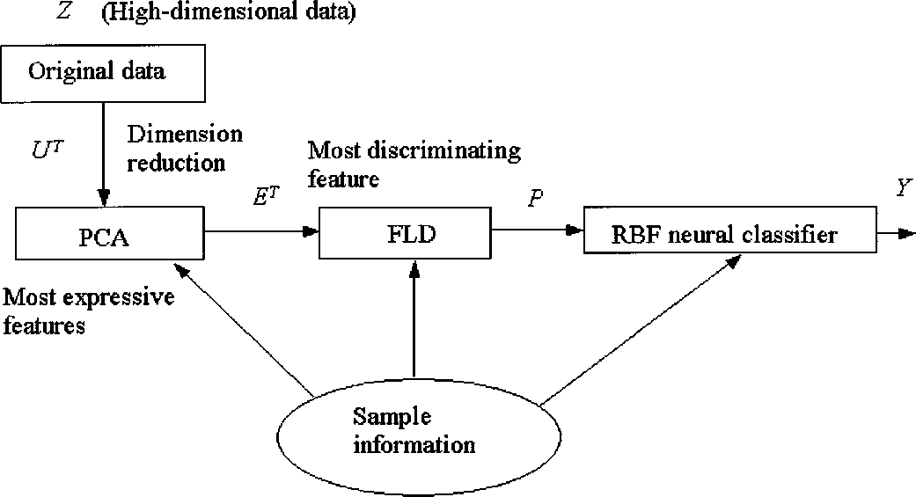

**Figure 6.** Schematic diagram of RBF neural classifier for small training sets of high dimensions.

Besides, occlusion detection where occlusion is condition where objects hide from another object is proposed in [26]. The research consists of four stages where back propagation neural network is used to find the age of human in the third stage it shows good performance when compared to other artificial neural networks.

1. **Convolutional neural network(CNN):** This method is proposed to detect faces from different angles and can handle occlusion to some extent and it is also shown that proposed method performance can be further improved by using better sample strategies and augmentation techniques [27]. The technique for active face recognition and acts consistently using human behaviors in usual face recognition scenarios is demonstrated. This network does visual processing more biologically possible which is relevant to application [28].
2. **Radial basis function(RBF):** An efficient design approach by considering radial basis function (RBF) neural classifier to maintain with small training sets of high dimensions and this occurs as problem frequently is demonstrated [29]. Data information is encapsulated in determining the structure and initial parameters of the RBF neural classifier before learning takes place. Training of the RBF neural networks is done by hybrid learning algorithm in which the dimension of the search space is drastically reduced in the gradient paradigm. Simulation results conducted on the ORL database show that the system achieves excellent performance both in terms of error rates of classification and learning efficiency.

A method for automatic real time face and mouth recognition using radial basis function networks is presented in [30] This research uses the motion information to localize the face region and facial features are extracted using multi-scale morphological erosion and dilation operations. The input for the radial basis function is facial and mouth features.

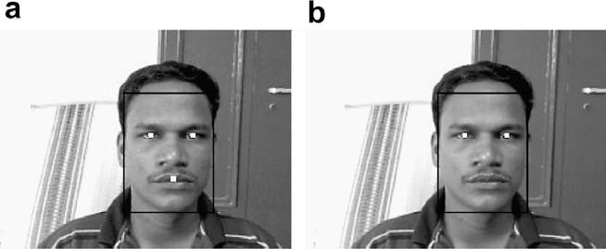

**Figure 7.** Determination of eye location: (a) centroids of the blobs and (b) locations of the eyes.

1. **Probabilistic neural network(PNN):** An algorithm which helps in facial recognition is proposed in [31]. This method includes three stages such as the incomplete wavelet packet decomposition of face image and training PNN classiﬁers with wavelet sub- images with low frequency components and at last, the combinations of the trained PNN classiﬁers by fuzzy integral. Compared with four matrix subspace algorithms, the proposed method can obtain

competitive performance. It also improves the accuracy of the face recognition with less CPU time.

A novel heuristic structure optimization methodology for radial basis probabilistic neural networks and this method achieves higher recognition rates and better classification efficiency than multiplayer perceptron networks is presented in [32]. This is the fusion of both radial basis functional neural networks and also probabilistic neural networks.

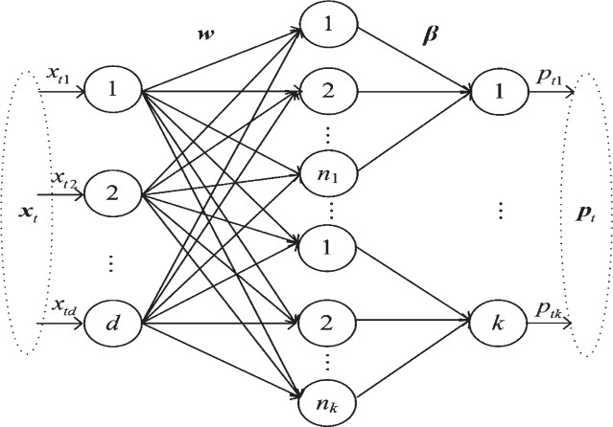

**Figure 8.** The probabilistic neural network trained with training set D.

**Table1.** Classification of Feature extraction techniques

1088

|  |  |  |  |  |
| --- | --- | --- | --- | --- |
| **SL.**  **NO** | **Paper Title** | **Technique Used** | **Outcomes** | **Research Gap** |
| 1. | Face recognition under pose variation with local gabor features enhanced by active shape and statistical models [10] | Active state model feature extraction method | 1. Highest accuracy with 2D face recognition methods. 2. More robust to changes   in general conditions | Does not show much performance for 3D methods |
| 2 | Facial component features for facial expression identification using active appearance models [13] | Active appearance model feature extraction method | 1. Higher classification rate is observed | The combination of model shape can be extended to use in facial recognition |
| 3 | Fuzzy match index for scale invariant features with application to face recognition with weak supervision [14] | Scale-invariant feature transform method is used | 1. Higher efficiency compared to different state of art methods 2. Excellent results of face   recognition under weak supervision | Varying efficiency as datasets gets increased |
| 4 | Face recognition using augmented local binary pattern and bray Curtis dissimilarity metric [16] | Augmented local binary pattern-based feature extraction | 1. Does better at recognizing faces in uncontrolled environments such as  facial expression | The LBP has taken the help of another metric to perform well |
| 5 | A cloud-based monitoring system via face recognition using gabor and CS-LBP feature [19] | Gabor binary pattern method is used for face recognition | 1. Both face detection face and recognition algorithms were verified to be suitable for ubiquitous monitoring | Here the effective speed should be increased in order to promote effective development of online real time recognition |
| 6 | Patch based principal component analysis for Face recognition [20] | Principal component analysis method | Promotes accuracy  compared to one  dimensional, two dimensional and two directional two- dimensional PCA | Different size of patches brings different identifying results |
| 7 | An Eye-Contour Extraction Algorithm from Face Image using Deformable Template  Matching | Deformable template-based extraction method | Cost function is not necessary in this algorithm | Not applicable to Japanese face images |

|  |  |  |  |  |
| --- | --- | --- | --- | --- |
| 8 | Gravity center template based human face feature detection [23] | Gravity center template-based extraction method | Simple and fast approach to characterize the scale sizes and shapes of human with complex background | It cannot  characterize few parts in face such as lips which makes the research to make better |

**Table 2.** Classification of artificial neural networks

|  |  |  |  |  |
| --- | --- | --- | --- | --- |
| **SL.**  **NO** | **Paper Title** | **Technique Used** | **Outcomes** | **Research Gap** |
| 1 | Active Face Recognition Using Convolutional Neural Networks [28] | Convolution neural networks | System is capable of performing real-time recognition, which makes it suitable for virtual human modeling applications. | The direction of the face must be estimated for more realistic active face  recognition. |
| 2 | Real time face and mouth recognition using radial basis function neural networks [30] | Radial basis function neural networks method | The face tracking and feature extraction techniques are computationally  efficient | Method is sensitive to shadows variation in lighting conditions and profile view of  the face |
| 3 | Ensemble of multiresolution probabilistic neural network classifiers with fuzzy integral for face recognition [31] | Probabilistic neural network method | 1. The proposed method can obtain competitive performance 2. It can improve the recognition with fast learning speed. | The problem of scalability, i.e.,  whether the algorithm can be extended to big data environment by  deploying the computation of fuzzy integral to different cloud computing nodes. |
| 4 | Decision tree-based occlusion detection in face recognition and estimation of human age using back propagation neural network [26] | Back propagation Neural network | Face verification was completed with 95% accuracy | Not 100% accurate |

1089

1. **CONCLUSIONS**

In this paper, the various techniques of feature extraction and neural networks which include active shape, radial basis function, convolutional, gravity center template, has been discussed. The eight different types of feature recognition methods among which template-based method and active shape model looks more efficient compared to the rest other techniques where these techniques also have their own limitations. In the next four neural classification techniques which are discussed above are taken into consideration and it is observed that back propagation neural network and convolutional neural network are found to be more accurate than the rest but these two also have minor limitations mainly scaling of the image .The future work can be improved by implementing a novel technique by integrating the limitations caused by the two techniques in feature recognition and also in neural classification and obtain more efficiency.

# REFERENCES

[1]. Biggio, B., Fumera, G., & Amp, Roli, F. (2014). Pattern recognition systems under attack: Design issues and research challenges. International Journal of Pattern Recognition and Artificial Intelligence, 28(07), 1460002.

[2]. B. Klare and A. K. Jain, (2010) "On a taxonomy of facial features," in Proc. 4th IEEE Int. Conf. Biometrics Theory, Applications and Systems (BTAS), Crystal City, Washington D.C.

[3]. Dapeng Tao , Yanan Guo, Yaotang Li, and Xinbo Gao (2018) "Tensor Rank Preserving Discriminant Analysis for Facial Recognition"IEEE transactions on image processing , VOL. 27, NO. 1.

[4]. Jian Yanga,b,David Zhanga,Xu Yongb, Jing-yu Yang:Two-dimensional discriminant transform for face recognition.

[5]. T. Ahonen, A. Hadid, (2006) and M. Pietikainen. Face description with local binary patterns: Application to face recognition.

TPAMI, 28(12):2037– 2041

[6]. Aude oliva,Antonio Torrolaba "Modeling the Shape of the Scene: A Holistic Representation of the Spatial Envelope

[7]. W.Zhao,R chellappa,P.J.philips,A Rosenfled Face recognition: A literature survey

[8]. Herve Abdi,Lyne J willia "Principal component analysis"

[9]. Anastasia Bolotnikova, Hasan Demirel, Gholamreza Anbarjafari1,"Real-time ensemble based face recognition system for NAO humanoids using local binary pattern",Analog Integr Circ Sig Process

[10]. Anastasia Bolotnikova, Hasan Demirel, Gholamreza Anbarjafari1,"Real-time ensemble based face recognition system for NAO humanoids using local binary pattern",Analog Integr Circ Sig Process.

[11]. Leonardo A. Camenta, Francisco J. Galdamesa, Kevin W. Bowyer, Claudio A. Pereza,(2015) "Face Recognition under Pose Variation with Local Gabor Features Enhanced by Active Shape and Statistical Models"

[12]. Yong-Hwan Lee , Cheong Ghil Kim , Youngseop Kim , Taeg Keun Whangbo, (2009) "Facial landmarks detection using improved active shape model on android platform", Springer Science Business Media New York.

[13]. Cootes T (2000) An Introduction to Active Shape Models. Image Processing and Analysis: A Practical Approach. Oxford University Press, pp. 223–248.

[14]. Odoyo O. Wilfred , Geum-Boon Lee , Jung-Jin Park , Beom-Joon Cho ,(2009)"Facial component features for facial expression identification using Active Appearance".

[15]. Seba susan , Abhishek jain, Aakash sharma, Shikhar verma,Siddarth jain,(2015)"Fuzzy match index for scale invariant feature transform

features application to face recognition with weak supervision", IET image processing.

[16]. Mohanraj , Vimalkumar, Mithila , Vaidehi,(2016) "Robust Face Recognition System in Video using Hybrid Scale Invariant Feature Transform", 6th International Conference On Advances In Computing & Communications.

[26]. Abhjeet Sekhon,Pankaj Agarwal,(2015)"Face recognition using back propagation neural network technique.

[27]. P. Karthigayani, S. Sridhar,(2014) "Decision tree based occlusion detection in face recognition and estimation of human age using back propagational network"Journal of Computer Science.

|  |  |  |  |
| --- | --- | --- | --- |
| [17]. | Radhey Shyam , Yogendra Narain Singh,(2015) " | [28]. | Sachin Sudhakar, Farfade Mohammad, Saberian, |
|  | Face Recognition using Augmented Local Binary |  | Li-Jia Li,(2015)"Multi-view Face Detection |
|  | Pattern and Bray Curtis Dissimilarity Metric". |  | Using Deep Convolutional Neural Networks". |
| [18]. | Anastasia Bolotnikova, Hasan Demirel, | [29]. | Tao Wang ; David J. Wu ; Adam Coates ; |
|  | Gholamreza Anbarjafari1,"Real-time ensemble |  | Andrew Y. Ng" End-to-end text recognition |
|  | based face recognition system for NAO |  | with convolutional neural networks". |
|  | humanoids using local binary pattern",Analog | [30]. | Meng Joo Er, Shiqian Wu, Juwei Lu, Hock Lye |
|  | Integr Circ Sig Process. |  | Toh, (2002) "Face Recognition With Radial Basis |
| [19]. | Leonardo A. Camenta, Francisco J. Galdamesa, |  | Function (RBF) Neural Networks. |
|  | Kevin W. Bowyer, Claudio A. Pereza,(2015) | [31]. | M Balasubramaniam,S |
|  | "Face Recognition under Pose Variation with |  | palanivel,V.ramalingam,(2009)"Real time face |
|  | Local Gabor Features Enhanced by Active Shape |  | and mouth recognition using radial basis |
|  | and Statistical Models. |  | function neural networks". |
| [20]. | Chen Li, Wei Wei, Jiaxue Li , Wei Song,(2016) " | [32]. | Junhai Zhaia,Wenxiu Zhaoc,(2016) "Ensemble |

cloud-based monitoring system via face recognition using Gabor and CS-LBP features"

[21]. Tai-Xiang Jiang, Ting-Zhu Huang, Xi-Le Zhao, Tian-Hui Ma,(2017)" Patch-Based Principal Component Analysis for Face Recognition".

[22]. Narayan T. Deshpande ,Dr. S. Ravishankar

,(2017)"Face Detection and Recognition using Viola-Jones algorithm and Fusion of PCA and ANN", Advances in Computational Sciences and Technology ISSN 0973-6107 Volume 10,

Number 5 (2017) pp. 1173-1189 .

[23]. Alan L. Yuille, Peter W. Hallian, David S . Cohen ,(1992) " Feature Extraction from Faces Using Deformable Templates", International Journal of Computer Vision, 8:2, 99-111.

[24]. Un Miao,Wen, Gao,Yi qiang ,Chen Jie, Lu v (2001) "Gravity-Center Template Based Human Face Feature Detection".

[25]. Xiaofan,Bao-caio-yan,Yan-Feng-sun."Yawning Detection for Monitoring Driver Fatigue".

of multiresolution probabilistic neural network classiﬁers with fuzzy integral for face recognition".

[33]. Tai-Xiang Jiang, Ting-Zhu Huang, Xi-Le Zhao, Tian-Hui Ma,(2017)" Patch-Based Principal Component Analysis for Face Recognition"